File Packer Unpacker

- This project is used to perform packing and unpacking activity for multiple types of files.

- In case of Packing activity me maintain one file which contains metadata and data of multiple files from specified directory.

- In case of Unpacking activity we extract all data from packed files and according to its metadata we create all files.

- In this project we have to use Java as Front end as well as Backend for platform independency.

**Steps to develop above project**

- Design one window which accept username and password from user for authentication purpose.

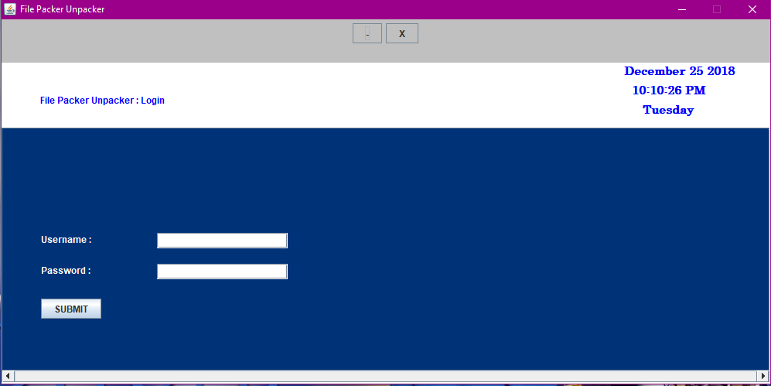

- When user submit the username and password we have to check whether username is “PackUnpackAdmin” and password is “PackUnpackAdmin”.

- If password or username is incorrect then we have to provide 3 attempts to user. I user is

unable to provide correct username and password in 3 attempts we have to close the project.

- For checking whether username and password contains minimum contains 8 letters or not

we have to create one thread. That thread also check whether caps lock key is on or not.

- After successful authentication we have to open new window which displays two options as Pack and Unpack.

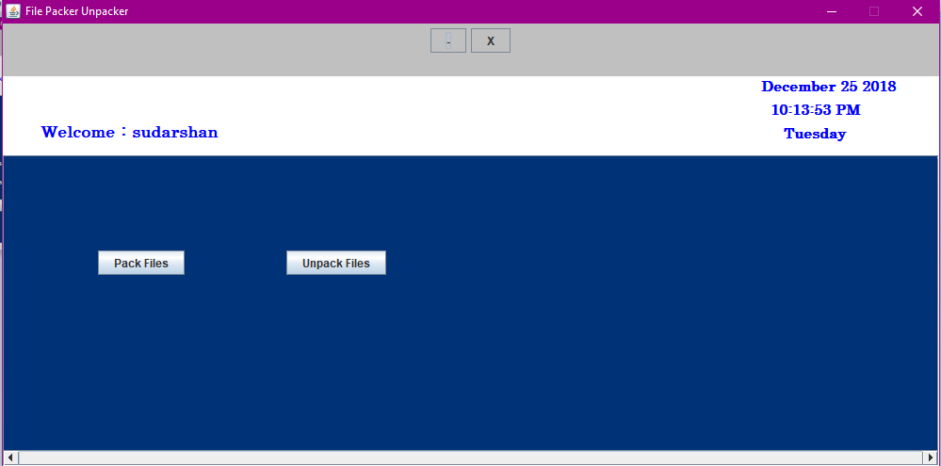

- When user press Pack button we have to open new window which looks like

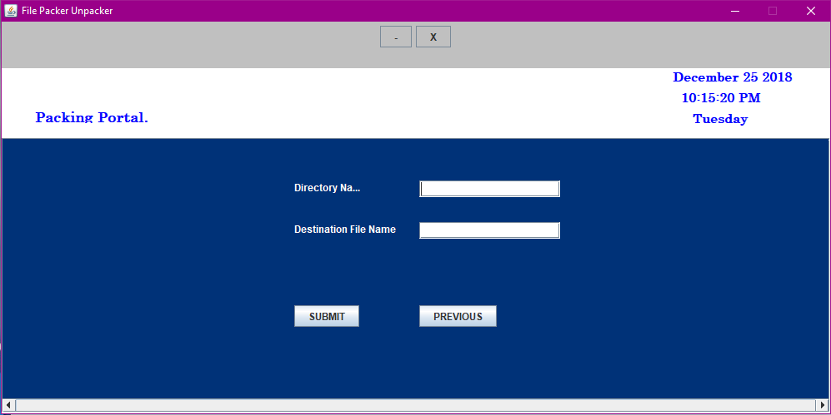

- From the above window we have to accept name of directory that we want to pack and name of the packed file from user.

- Name of the packed file gets newly created which contains data and metadata of all files from that directory.

- When user click submit button we have to perform “Packing Activity”. After that previous window should be displayed as



- When user click Unpack button below window should be displayed as

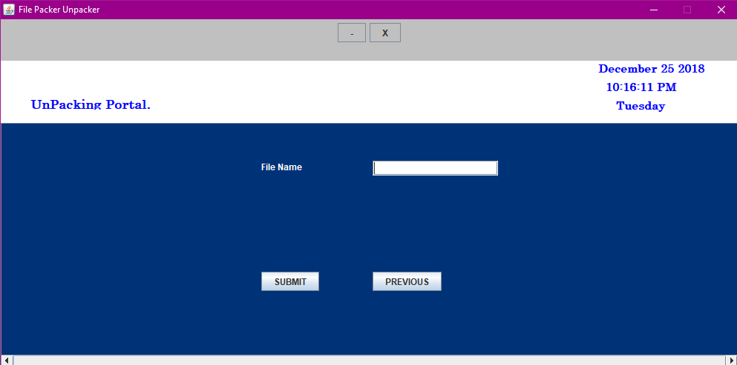

- From this window accept name of packed file.

- When user click UBMIT button we have to perform “Unpacking Activity”.

Backend Logic

Packing Activity :

• In case of Packing activity we accept directory name and file name from user.

• We have to create new regular file as the name specified by the user.

• Now open the directory and traverse each file from that directory. In newly created file

write Metadata as header and actual file data in sequence.

• While writing data perform encryption.

• Each name of file ,its size and checksum should be written in log file which gets created in

system directory.

• After packing display packing report.

UnPacking Activity :

• In case of UnPacking activity we accept packed file name from user.

• for authentication of packed file use any logic like Magic Number.

• Open the packed file in read mode and perform below activity as

• Read header

• From the name specified in header create new file.

• Write data into newly created file from packed file.

• Repeat all above steps till we reached at end of the file unpacked file.

• After unpacking display unpacking report.